SCHOOL OF COMPUTER SCIENCE AND ARTIFICIAL INTELLIGENCE |  |  |  |  | DEPARTMENT OF COMPUTER SCIENCE ENGINEERING
Program Name: B. Tech |  |  |  | Assignment Type: Lab |  |  | Academic Year:2025-2026
Course Coordinator Name |  |  |  | Venkataramana Veeramsetty
Instructor(s) Name
  Dr. V. Venkataramana (Co-ordinator)
  Dr. T. Sampath Kumar
  Dr. Pramoda Patro
  Dr. Brij Kishor Tiwari
  Dr.J.Ravichander
  Dr. Mohammand Ali Shaik
  Dr. Anirodh Kumar
  Mr. S.Naresh Kumar
  Dr. RAJESH VELPULA
  Mr. Kundhan Kumar
  Ms. Ch.Rajitha
  Mr. M Prakash
  Mr. B.Raju
  Intern 1 (Dharma teja)
  Intern 2 (Sai Prasad)
  Intern 3 (Sowmya)
  NS_2 ( Mounika)
Course Code |  |  | 24CS002PC215 | Course Title |  | AI Assisted Coding
Year/Sem |  |  | II/I | Regulation |  | R24
Date and Day  of Assignment |  |  | Week10 - Monday | Time(s)
Duration |  |  | 2 Hours | Applicable to  Batches
AssignmentNumber:20.1(Present assignment number)/24(Total number of assignments)
 | Q.No. | Question |  |  |  |  |  | Expected Time  to complete
 | 1 | Lab 20 – Security Testing: Identifying Vulnerabilities in AI-Generated Code  Lab Objectives:  - Understand how to test AI-generated code for common security vulnerabilities.  - Learn to apply secure coding principles while analyzing AI outputs.  - Practice detecting risks such as SQL injection, XSS, hardcoded credentials, and weak encryption.  - Enhance code reliability and safety by using AI for secure refactoring.  Task 1 – Input Validation Check  Task:  Analyze an AI-generated Python login script for input validation vulnerabilities.  Instructions:  - Prompt AI to generate a simple username-password login program.  - Review whether input sanitization and validation are implemented.  - Suggest secure improvements (e.g., using re for input validation).  Expected Output:  - A secure version of the login script with proper input validation.  PROMPT:  Generate a simple Python script that asks a user to input a username and password to log in. Then, analyze the script for input validation or sanitization vulnerabilities. Identify any security risks in how the input is handled, and explain what should be improved. Finally, rewrite the script to make it more secure by adding proper input validation using regular expressions (the re module) and other safe coding practices.  CODE:  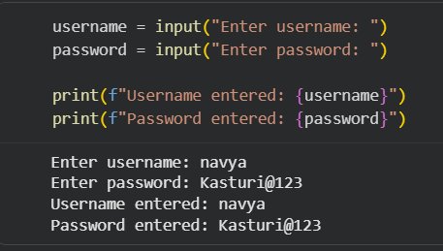  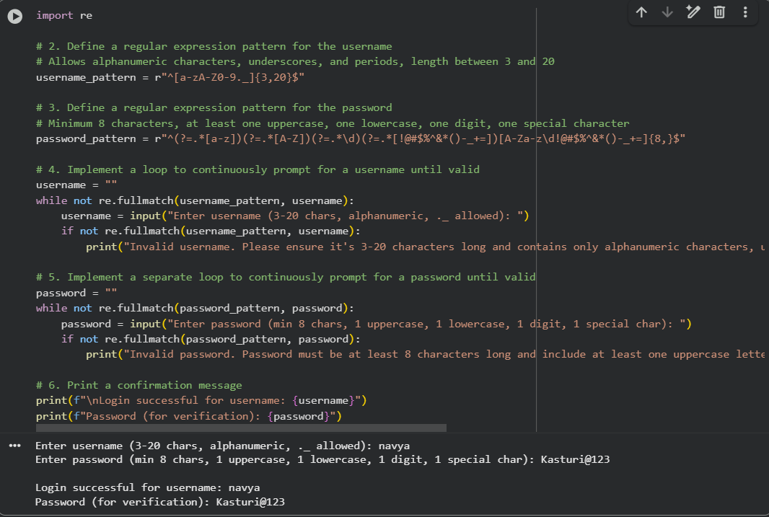  Task 2 – SQL Injection Prevention  Task:  Test an AI-generated script that performs SQL queries on a database.  Instructions:  - Ask AI to generate a Python script using SQLite/MySQL to fetch user details.  - Identify if the code is vulnerable to SQL injection (e.g., using string concatenation in queries).  - Refactor using parameterized queries (prepared statements).  Expected Output:  - A secure database query script resistant to SQL injection.  PROMPT:  Generate a Python code snippet for a basic login form using Flask that accepts username and password from a user and checks credentials against a database. Then perform a security audit on the code to identify vulnerabilities such as SQL injection, plaintext password storage, or lack of input validation. After that, provide a secure version of the code using best practices like parameterized queries, password hashing, and input sanitization. Show both insecure and secure versions side by side with explanations.  CODE:  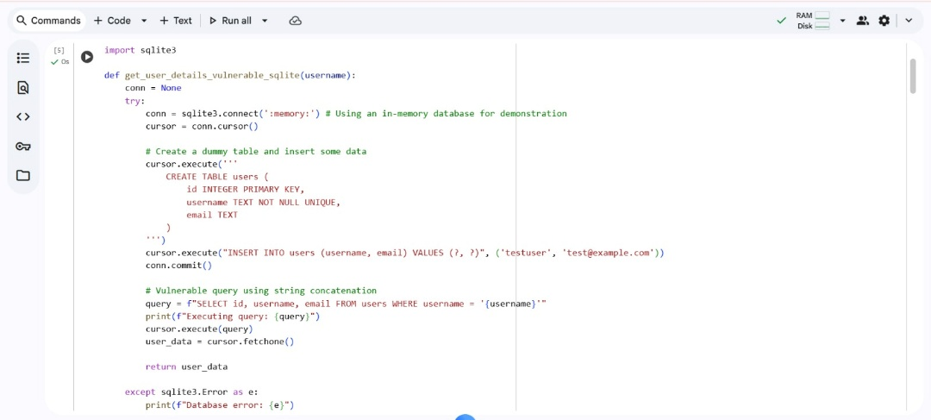  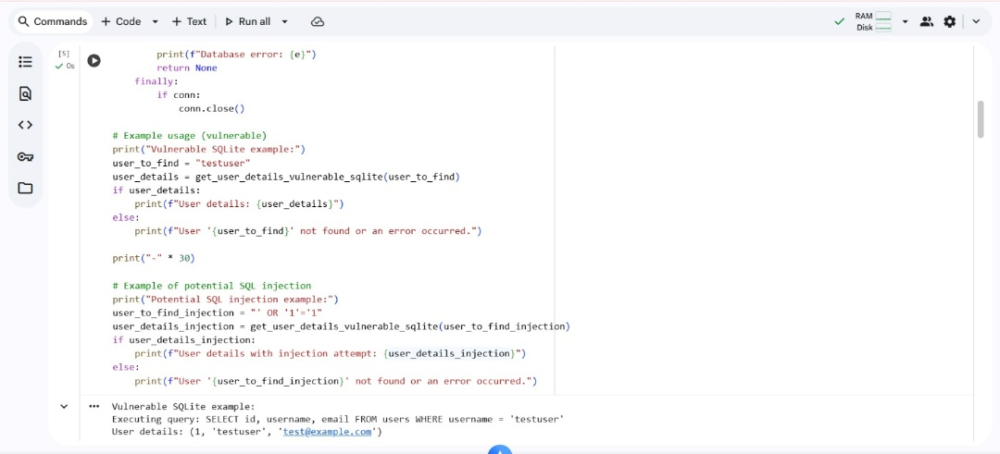  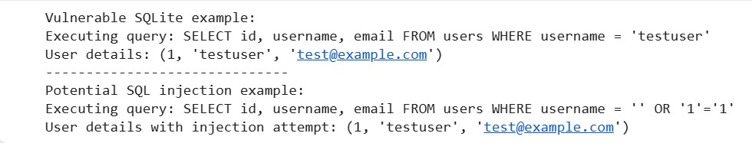  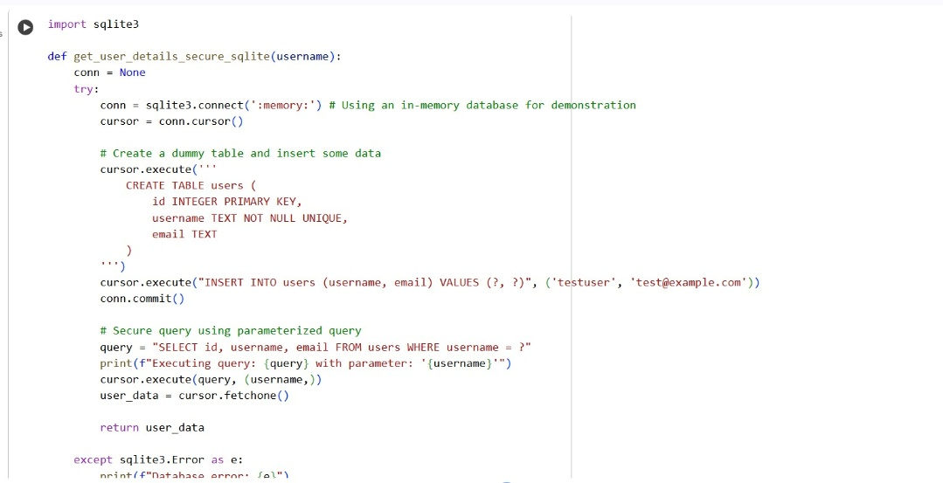  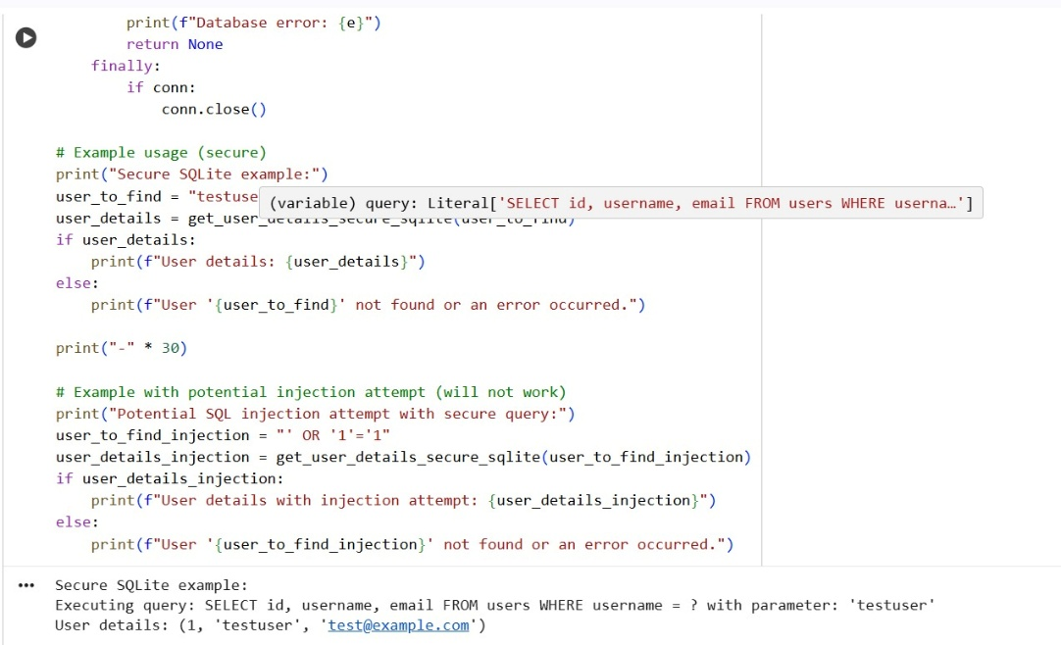  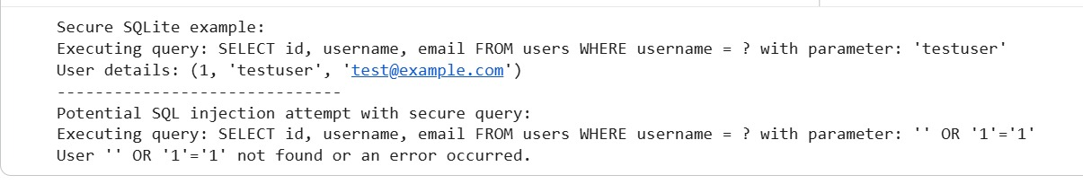  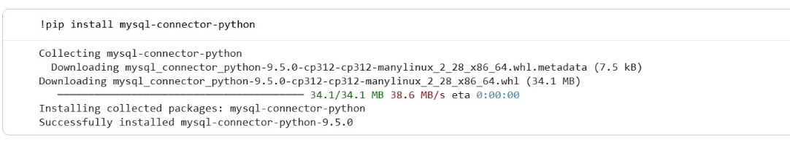  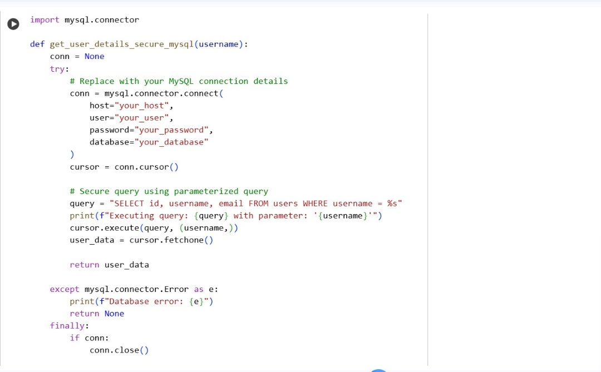  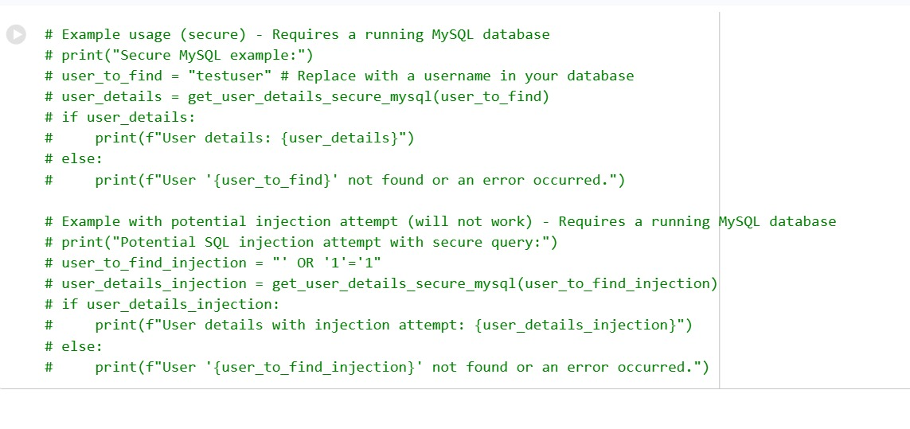  Task 3 – Cross-Site Scripting (XSS) Check  Task:  Evaluate an AI-generated HTML form with JavaScript for XSS vulnerabilities.  Instructions:  - Ask AI to generate a feedback form with JavaScript-based output.  - Test whether untrusted inputs are directly rendered without escaping.  - Implement secure measures (e.g., escaping HTML entities, using CSP).  Expected Output:  - A secure form that prevents XSS attacks.  PROMPT:  Generate a simple HTML feedback form that uses JavaScript to display the user's submitted feedback on the same page. Then, analyze the code for potential Cross-Site Scripting (XSS) vulnerabilities—specifically checking if untrusted user input is rendered directly into the page without escaping. Identify any security risks and explain how to fix them. Finally, rewrite the form securely by escaping HTML entities, validating inputs, and adding protections such as a Content Security Policy (CSP).  CODE:  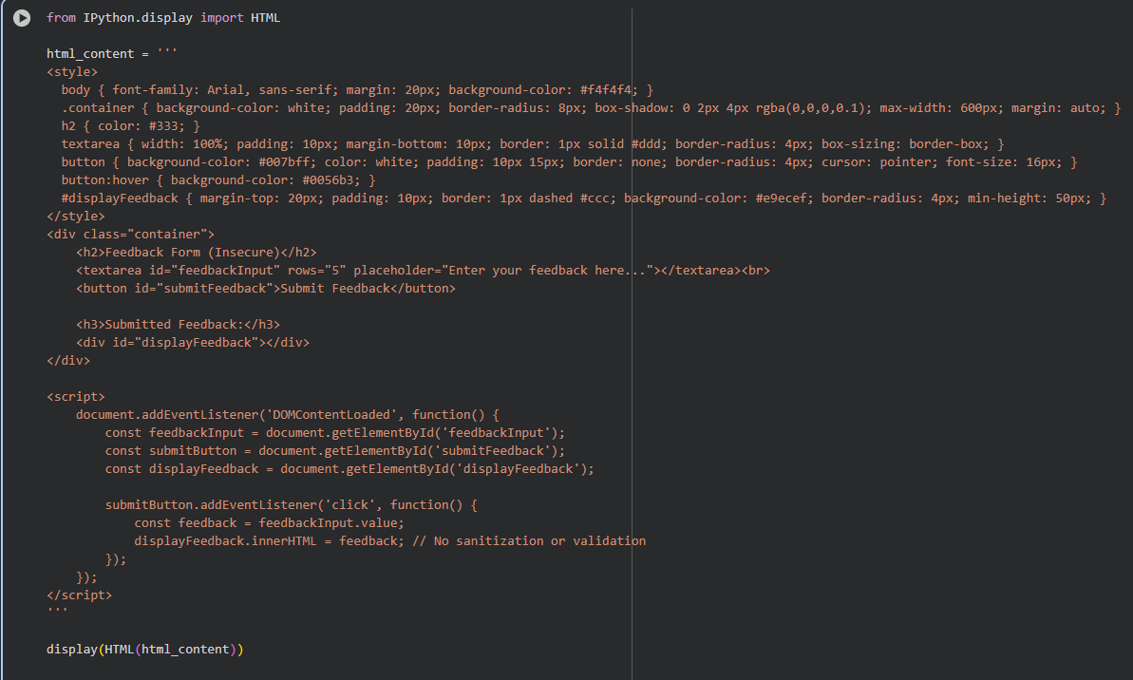  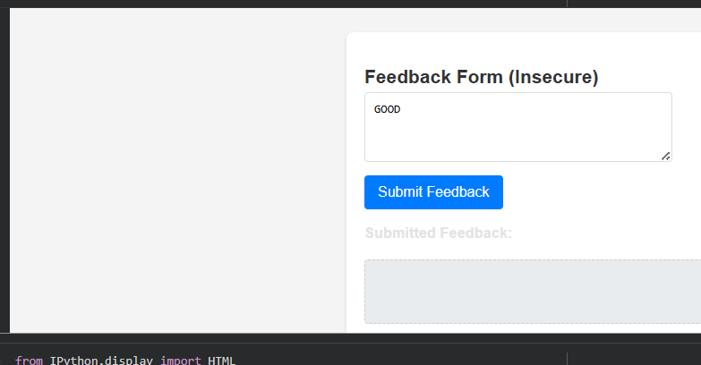  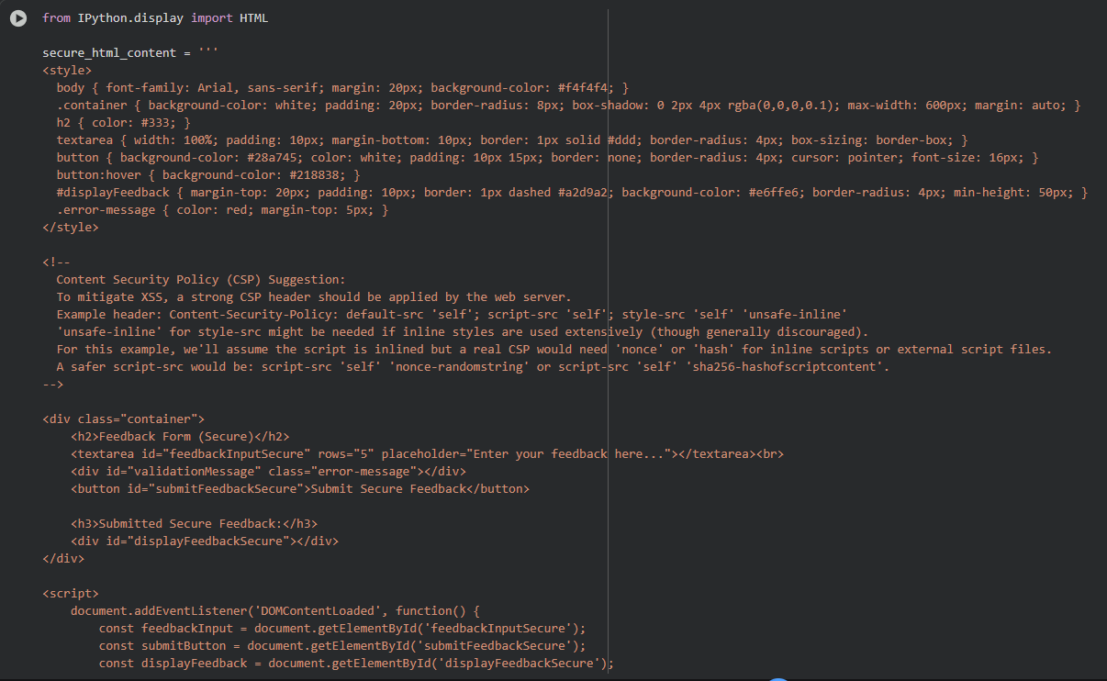  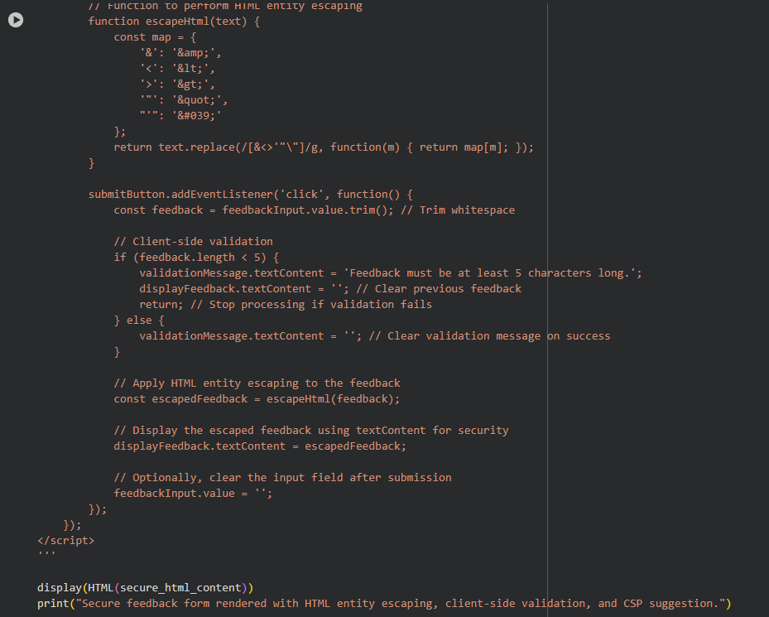  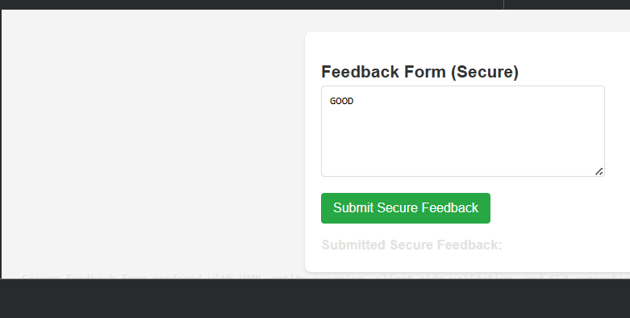  Task 4 – Real-Time Application: Security Audit of AI-Generated Code  Scenario:  Students pick an AI-generated project snippet (e.g., login form, API integration, or file upload).  Instructions:  - Perform a security audit to detect possible vulnerabilities.  - Prompt AI to suggest secure coding practices to fix issues.  - Compare insecure vs secure versions side by side.  Expected Output:  - A security-audited code snippet with documented vulnerabilities and fixes.  PROMPT:  Provide a small Python project snippet, such as a login form, API integration, or file upload functionality. Then, perform a detailed security audit of the code. Identify all potential vulnerabilities (e.g., input validation issues, SQL injection, file upload risks). Suggest secure coding practices to fix these issues, and rewrite the code in a secure version. Present both the insecure and secure versions side by side, with comments explaining the vulnerabilities and how they were fixed.  CODE:  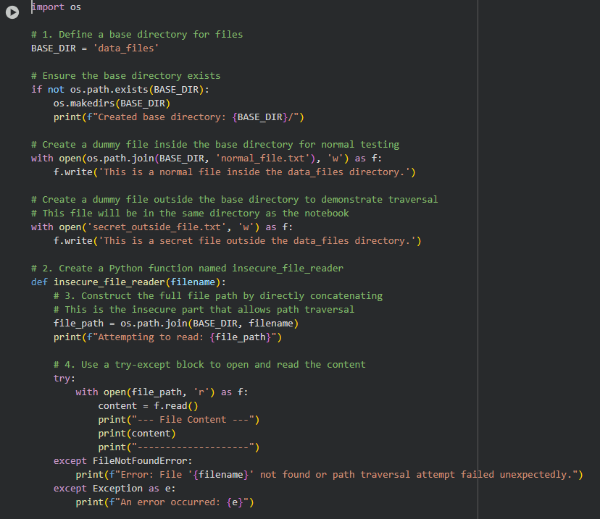  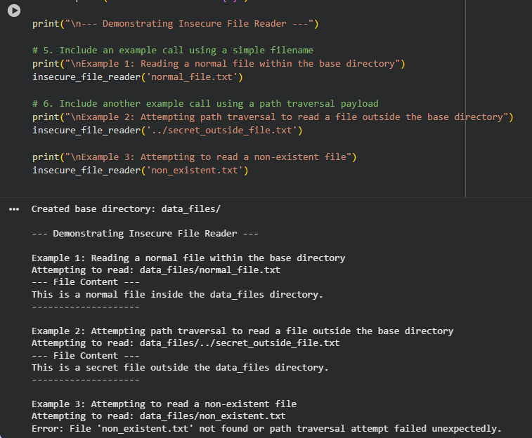  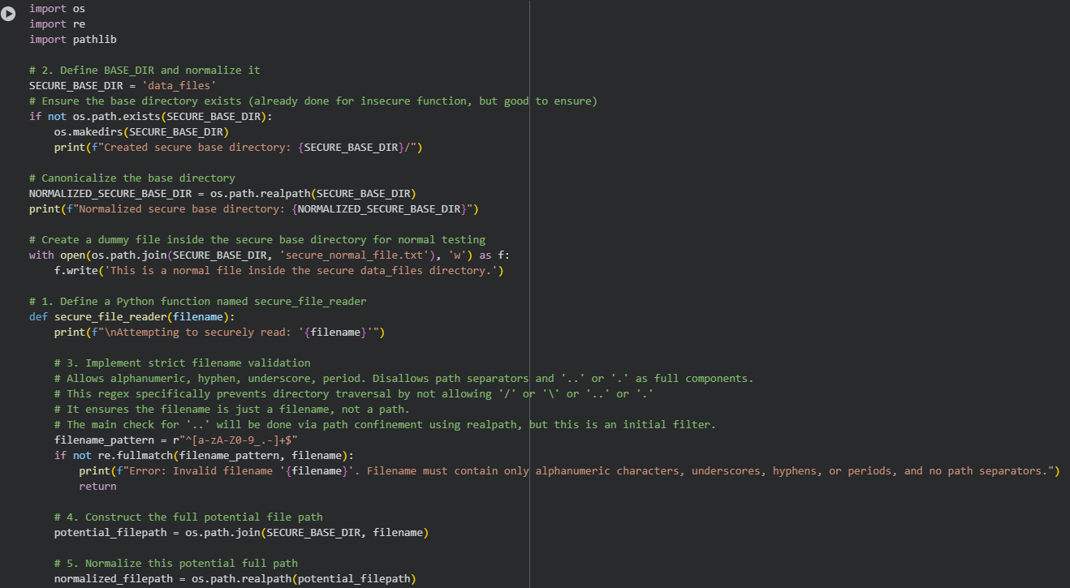  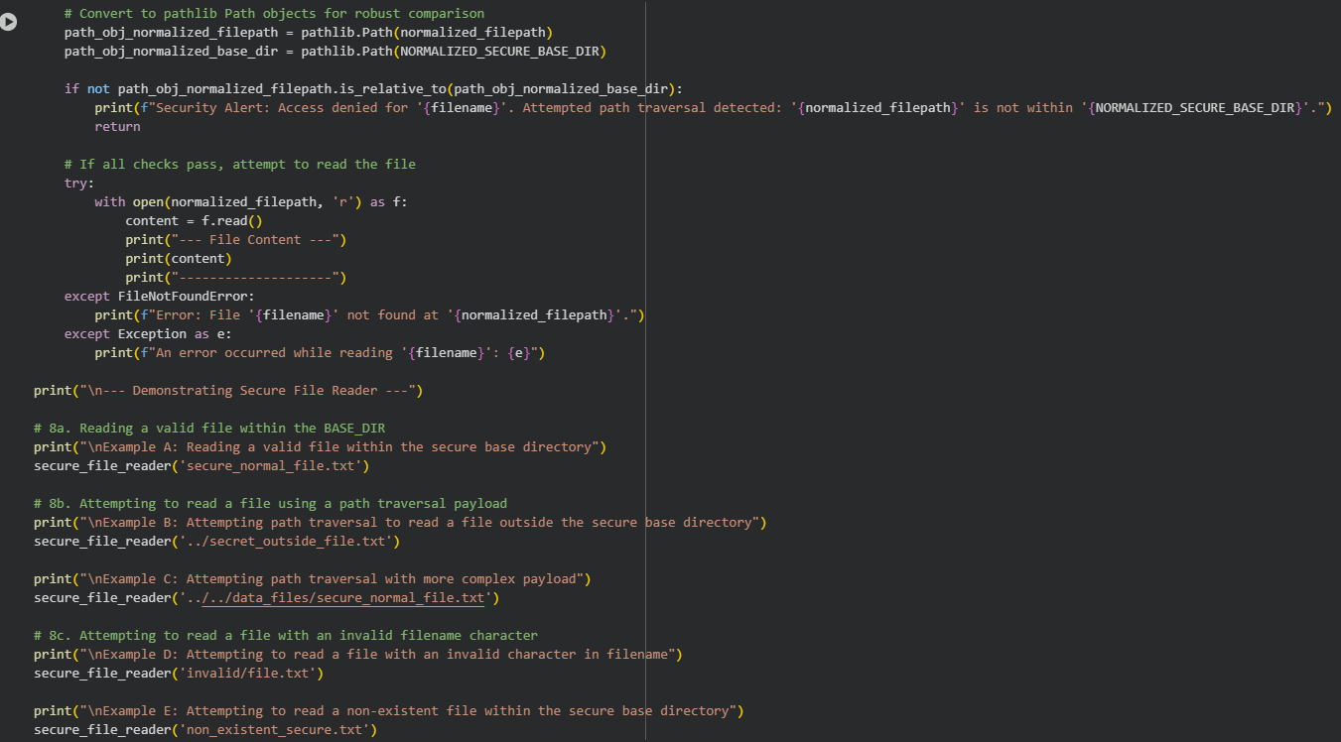  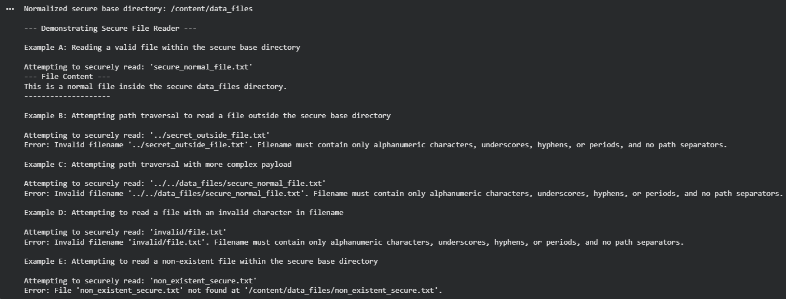  ✅ Deliverables (For All Tasks)  - AI-generated prompts for code and test case generation.  - At least 3 assert test cases for each task.  - AI-generated initial code and execution screenshots.  - Analysis of whether code passes all tests.  - Improved final version with inline comments and explanation.  - Compiled report (Word/PDF) with prompts, test cases, assertions, code, and output. |  |  |  |  |  | Week10 - Monday

